Tableau Day 2 - Exercises

Exercise 1

1. For these exercises, we will be using the ‘employee’ tables. Import the files **employee.csv** and **department.csv** into Tableau from your data directory.

Answer :

Import the .csv files from the data folder with the Connect panel.

1. Perform a left join between employee.csv and department.csv. Click the join drawing and find out which column is used for this join.

Answer: Dept Id is the column used for this join.

1. Perform a full outer join between the employee and department tables. How many rows are returned by this join? (You can see the number of rows on the right corner of the bar below the joins.)

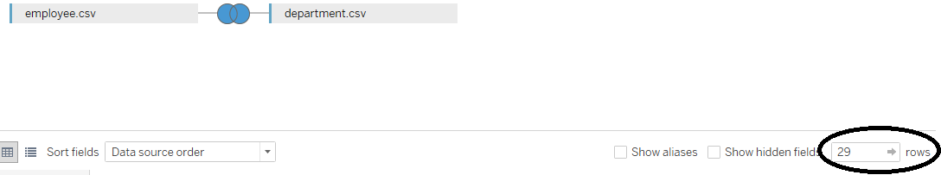

Answer: 29

1. Now, import the project table, **project.csv**, into Tableau. Perform an inner join with the employee table. Perform an inner join on the employee and department tables, and then a left join on the employee and project tables.

Answer:

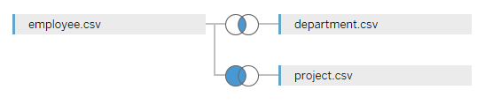

Exercise 2

1. On a new sheet, create a shape plot of Years of Experience vs. Employee Age colored by Dept Name, with Employee ID in the Detail field.

Answer:

* 1. Add Employee Id to the Detail field
  2. Add Employee Age(SUM) to the Column shelf
  3. Add Years of Experience(SUM) to the Row shelf
  4. Add Dept Name to the Color field

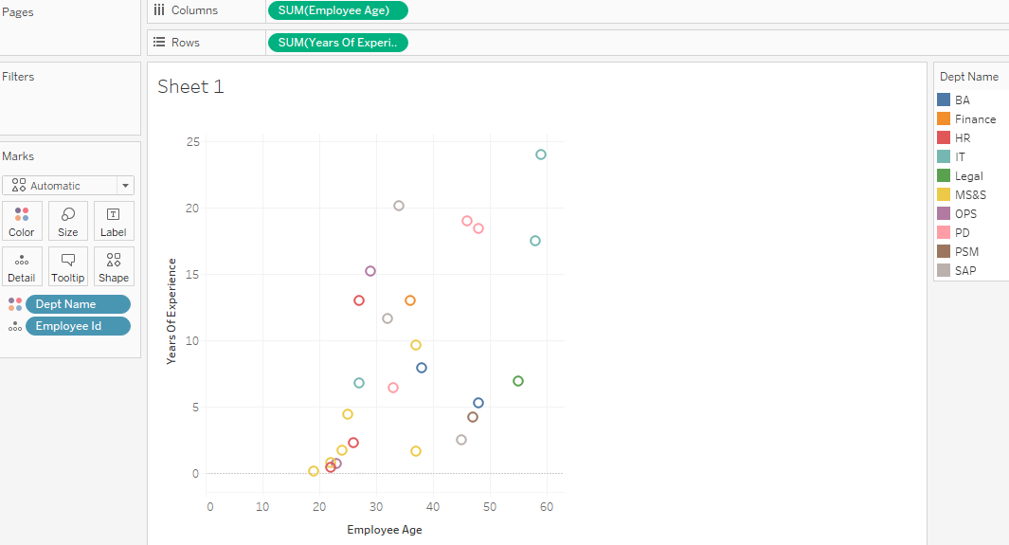

1. On a new sheet, plot a vertical bar chart to show Average Employee Age for each Project Name. Remove the Null bar by right-clicking on it and selecting “Exclude”.

Answer:

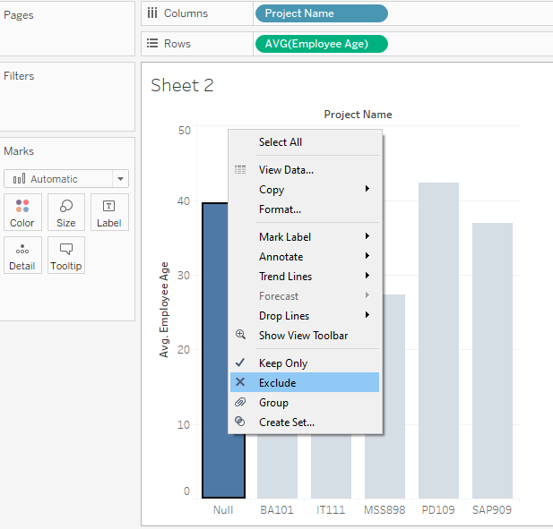

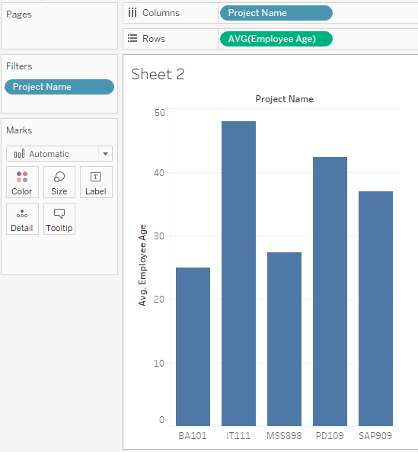

1. Using the Analytics tab, add a Mean (Average) line for Employee Age with 95% Confidence Interval (CI) to the chart obtained in Question 2.

What can you infer from the resulting chart?

Answer:

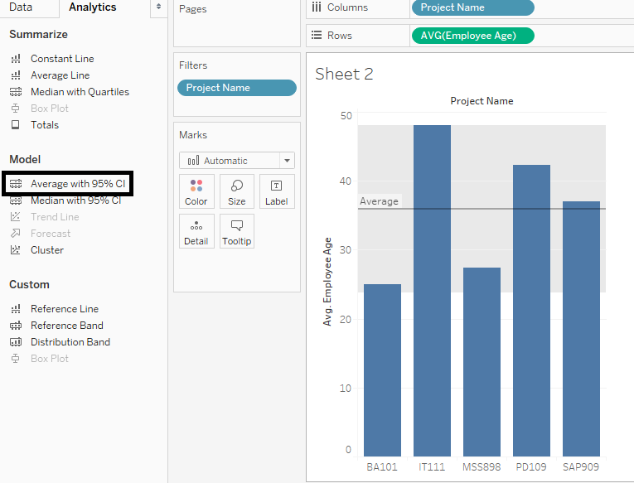

The Mean line shows us the overall Average Employee Age for all Projects.

We can see that the Average Employee Ages for the Projects BA101 and MSS898 are less than the overall Average Employee Age, while those of IT111, PD109 are greater than the overall Average Employee Age.

The average age of the SAP909 project is very similar to the overall average age of all Employees.

1. On a new sheet, plot a bar chart showing Total Employees for each Dept Name. Make sure that the Total Employee column is aggregated as an Attribute.

Answer:

1. Sort the bars in descending order of the Total Employee column.

Which two departments have the largest number of employees?

Answer:

PSM and MS&S have the largest number of employees by a large margin.

1. Now bin the Total Employee column using a bin size of 500, and color by Dept Name. How many bins do you see?

Answer: 4

